**Financial Domain Query Report**

1. **Bank Loan Report - Summary**

**KPI’s:**

**Total Loan Applications:**

select count(id) as Total_Loan_Applications from financial_loan



**MTD Loan Applications:**

select count(id) as MTD_Loan_Applications from financial_loan

where month(issue_date) = 12 and year(issue_date) = 2021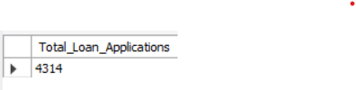

**PMTD Loan Applications:**

select count(id) as PMTD_Loan_Applications from financial_loan

where month(issue_date) = 11 and year(issue_date) = 2021

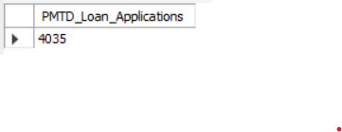

**Total Funded Amount:**

select sum(loan_amount) as Total_Funded_Amount from financial_loan

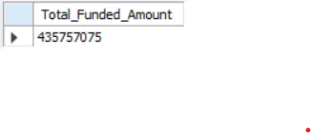

**MTD Total Funded Amount:**

select sum(loan_amount) as MTD_Total_Funded_Amount from financial_loan

where month(issue_date) = 12 and year(issue_date) = 2021

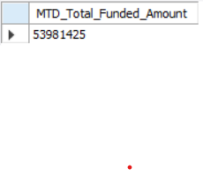

**PMTD Total Funded Amount:**

select sum(loan_amount) as PMTD_Total_Funded_Amount from financial_loan

where month(issue_date) = 11 and year(issue_date) = 2021

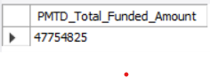

**Total Amount Received:**

select sum(total_payment) as Total_Amount_Received from financial_loan

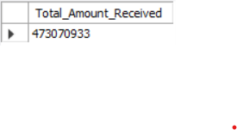

**MTD Total Amount Received:**

select sum(total_payment) as MTD_Total_Amount_Received from financial_loan

where month(issue_date) = 12 and year(issue_date) = 2021



**PMTD Total Amount Received:**

select sum(total_payment) as PMTD_Total_Amount_Received from financial_loan

where month(issue_date) = 11 and year(issue_date) = 2021

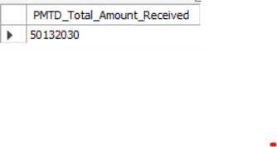

**Average Interest Rate:**

select avg(int_rate) * 100 as Average_Interest_Rate from financial_loan

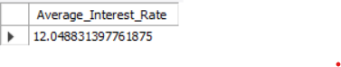

**MTD Average Interest Rate:**

select avg(int_rate) * 100 as MTD_Average_Interest_Rate from financial_loan

where month(issue_date) = 12 and year(issue_date) = 2021



**PMTD Average Interest Rate:**

select avg(int_rate) * 100 as PMTD_Average_Interest_Rate from financial_loan

where month(issue_date) = 11 and year(issue_date) = 2021



**Average DTI:**

select avg(dti) * 100 as Average_DTI from financial_loan



**MTD Average DTI:**

select avg(dti) * 100 as Average_DTI from financial_loan

where month(issue_date) = 12 and year(issue_date) = 2021

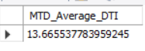

**PMTD Average DTI:**

select avg(dti) * 100 as Average_DTI from financial_loan

where month(issue_date) = 11 and year(issue_date) = 2021



**GOOD LOAN ISSUED:**

**Good Loan Percentage:**

**Good Loan Applications:**

**Good Loan Funded Amount:**

**Good Loan Amount Received:**

**BAD LOAN ISSUED:**

**Bad Loan Percentage:**

**Bad Loan Applications:**

**Bad Loan Funded Amount:**

**Bad Loan Amount Received:**

**LOAN STATUS:**

1. **Bank Loan Report – Overview**

**Month:**

**State:**

**Term:**

**Employee Length:**

**Purpose:**

**Home Ownership:**